3rd NanoBio Surfaces and Interfaces in Healthcare and Science Workshop
May 8-9, 2018
EPFL, Lausanne, Switzerland
Chair: Prof. Philippe Renaud (EPFL)
Keynote speakers:
Roland Zengerle, Hahn-Schickard-Director Freiburg & Villingen-Schwenningen
Emmanuel Delamarche, IBM
3rd & final call for presentations / abstracts / demo's
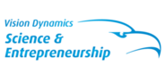 |  | 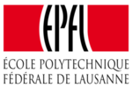
Chair: Prof. Philippe Renaud (EPFL)  Co-chair: Harald van Lintel (EPFL)  Program director: Hugo de Haan (Vision Dynamics Science & Entrepreneurship-  Organized in cooperation with Alps region ISC members |  | Including  - 2-day workshop  - 60+ scientific lectures  - Max 15 Table top demonstrations  - 8 May Cocktails & Poster session of  Philippe Flückiger’s CMi @ Rolex Center  - Evening dinner / Social event
Registration and abstract upload for speakers.
Abstract uploads before April 1st!

Preliminary Program & More info:  see www.visiondynamics.nl  Preliminary Speakers  8 May  Alessandro Patelli, Aliki Tsopela, Alquin Stevens, Andrea Valsesia, Anke Schuetz-Trilling, Arnaud Nicolas, Christian Mathis, Etienne Fradet, Giovanna Brusatin, Hatice Altug, Héctor Martínez, Hywel Morgan, Iwan Märki, John Brennan, Jörg Funk, Katja Fricke, Maurits van der Heiden, Maurizio Ventre, Maximilien Guerin, Morteza Aramesh, Norman D.H. Munroe, Pascal Jonkheijm, Paul Jacobs, Peter Miethe, Philippe Renaud, Roland Zengerle, Samuele Tosatti, Serena Danti, Stavros Stavrakis, Stefan Giselbrecht, Thomas Pfohl, Wilfried Weigel, Wolfgang Wagermaier  9 May  Albert van den Berg, Björn Önfelt, Dmitri Y. Petrovykh, Elmar Hartmann, Fredrik Höök, Hugo Bissig, Iago Pereiro, Jeff Wood, Jonathan M. Cooper, Joost Lötters, Maarten Honing, Marie-Agnès Doucey, Marileen Dogterom, Matthias Lutolf, Monika Ritsch-Marte, Murali Ghatkesar, Samantha Paoletti, Sami Rtimi, Tom Constandse, Tony Cass, Uwe Marx, Wim De Malsche  Cmi day track 8 may 15.45 hrs ;  Philippe Renaud, Jamie Paik, Jochen Zimmer (NanoScribe) |  | Firms presenting / table top demonstrations  Hotels:  see website
Key topics and themes:  - Human diagnostic devices  - Surface functionalization for coatings and dispensing  - Antimicrobial/ antifouling coatings & dispensing  - Analytics, detection and imaging  - Drug delivery systems  - Nanomedicine  - Cell-material interaction  - Organ on chip devices  - Novel screening methods  - Bio-inspired and bio-based chemistry |  | Previous workshops:  - Plasma 2014, Eindhoven  - Plasma 2015, Ghent  - NanoBio 2016, Enschede  - Plasma 2016, Braunschweig  - NanoFabrication 2017, Eindhoven  - NanoBio 2017, Leuven  - Plasma 2017, Orléans
Please contact hugo.dehaan@visiondynamics.nl for more information!
Visit www.visiondynamics.nl for registration and abstract upload for speakers.
Abstract uploads before April 1st!

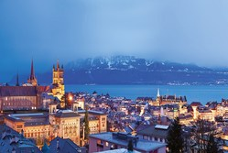 |  | 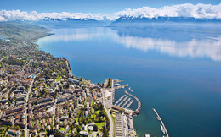
Workshop venue: Lausanne, Switzerland

Researchers and scientists from public and private sector can use JRC laboratories and facilities
Find out more on the OPEN CALL to access the JRC Nanobiotechnology!
